[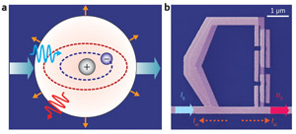](http://www.rikenresearch.riken.jp/images/figures/hi_4324.jpg)